Leg Muscles

Leg/Thigh
Fig.1 Rectus femoris. (posterior view) | Rectus femoris  Origin: Hip  Insertion: Patella, via ligament to Tibia  Action: Flex hip, extend knee

Fig.2 Vastus lateralis, vastus medialis  and Vastus intermedius. (anterior view) | Vastus lateralis  Origin: Femur  Insertion: Patella  Action: Extend knee  Vastus medialis  Origin: Femur  Insertion: Patella  Action: Extend knee  Vastus intermedius  Origin: Femur  Insertion: Patella  Action: Extend knee

Fig.3 Biceps femoris. | Biceps femoris  Origin: Hip  Insertion: Tibia, Fibula  Action: Flex knee, lateral rotation

Fig.4 Semimembranosus. | Semimembranosus  Origin: Hip  Insertion: Tibia, Fibula  Action: Flex knee, medial rotation  Semitendinosus  Origin: Hip  Insertion: Tibia, Fibula  Action: Flex knee, medial rotation

Fig.5 Adductor longus and Adductor magnus. | Adductor longus  Origin: Hip  Insertion: Femur  Action: Adduction, lateral rotation  Adductor magnus  Origin: Hip  Insertion: Femur  Action: Adduction, lateral rotation

Fig.6 Adductor brevis and Gracilis. | Adductor brevis  Origin: Hip  Insertion: Femur  Action: Adduction, lateral rotation  Gracilis  Origin: Hip  Insertion: Tibia  Action: Thigh adduction, flex knee

Fig.7 Sartorius | Sartorius  Origin: Hip  Insertion: Tibia  Action: Flex knee, flex and laterally rotate hip joint

Lower leg
Fig.8 Gastrocnemius. | Gastrocnemius  Origin: Femur  Insertion: Calcaneum  Action: Plantarflexion

Fig.9 Soleus. | Soleus  Origin: Tibia and Fibula  Insertion: Calcaneum  Action: Plantarflexion

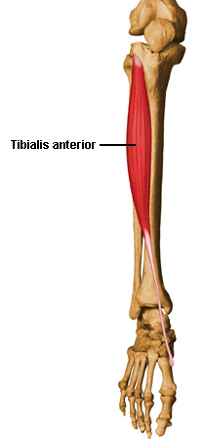  Fig.10 Tibialis anterior. | Tibialis anterior  Origin: Tibia  Insertion: 1st Metatarsal  Action: Dorsiflexion and inversion (lateral rotation)

Fig.11 Peroneus longus. | Peroneus longus  Origin: Fibula  Insertion: 1st Metatarsal  Action: Plantarflexion and eversion/pronation (medial rotation)

Fig.12 Flexor digitorum longus. | Flexor digitorum longus  Origin: Tibia  Insertion: Phalanges  Action: Dorsiflexion

Fig.13 Extensor digitorum longus. | Extensor digitorum longus  Origin: Tibia  Insertion: Phalanges  Action: Dorsiflexion

Fig.14 Extensor hallucis longus. | Extensor hallucis longus  Origin: Fibula  Insertion: 1st Phalange  Action: Dorsiflexion and inversion

