Axial and Appendicular Bones
Axial Bones
These are the bones that form the trunk of the body. The cranium is included in this definition.
Appendicular Bones
These are bones that form appendages to the body, i.e. arms and legs.
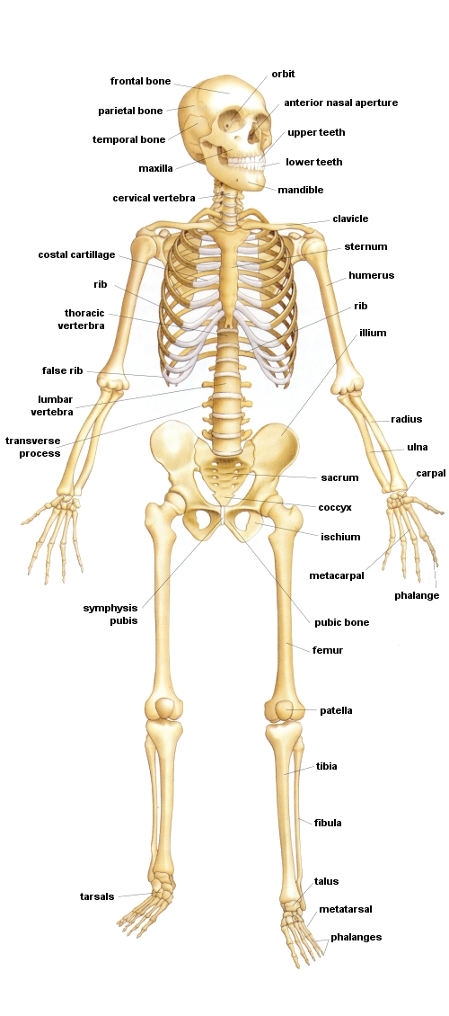
Fig.1 Bones of the Body. (anterior)
Fig.2 Bones of the Body. (posterior)

