Facial Bones
Nasal
Small Paired bones that fuse to form the bridge of the nose.
Lacrimal
Paired bones, each about the size of a fingernail. They are the smallest bones in the face. Posterior and lateral to the Nasal bones.
Mandible
Lower jaw bone. It is the largest and strongest of the facial bones and is the only moveable skull bone.
Turbinator
Bottom of the nasal cavity.
Hyoid
Suspended from the temporal bone between the mandible and the larynx.
Palatine
Paired L-shaped bones forming the posterior of the palate and part of the floor of the nasal cavity.
Maxilla
Paired bones forming the upper jaw. They also form part of the floor of the orbits, part of the roof of the mouth and part of the nasal cavity.
Zygomatic
Paired cheek bones that form the shape of the cheeks and part of the outer wall of the orbits.
Vomer
Inferior and posterior part of the nasal septum - the remainder is cartillage.
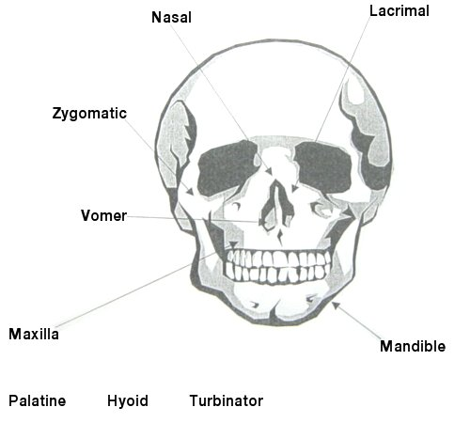
Fig.1 Facial Bones.

