Anatomical Terminology

When refering to the body, three planes are used as reference; the coronal, saggital (or median) and transverse planes:
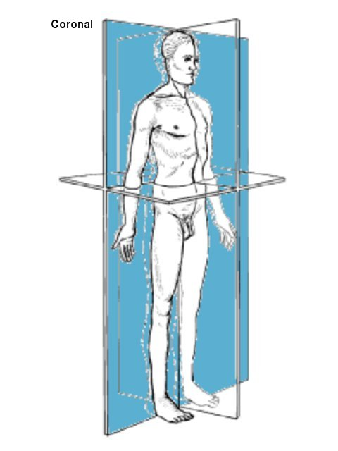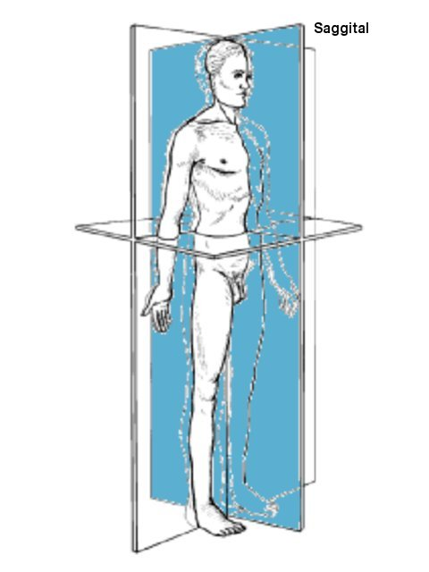
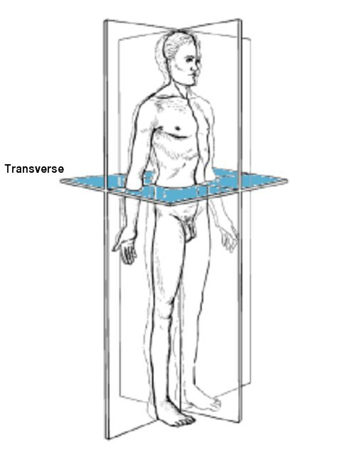
Fig.1 Anatomical Planes.

The anatomical position refers to the body placed in the position illustrated to the left below:
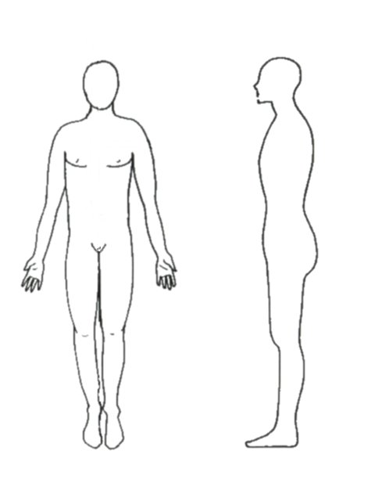
Fig.2 The Anatomical Position.

The planes are absolute terms. When referring to a part of the body, it can be referred to relative to another part of the body.

The terms Lateral and Medial are relative to the Median (the Saggital Plane).
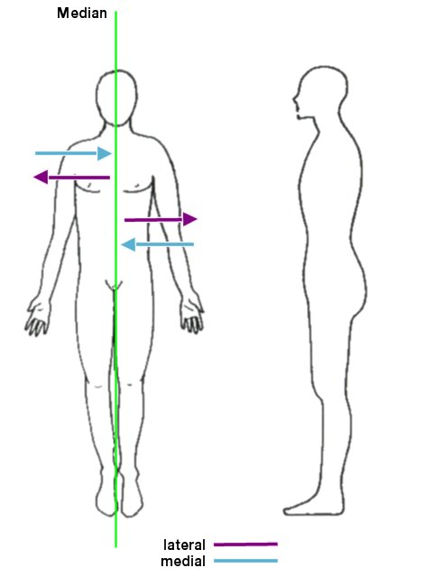

The terms Superior and Medial are relative to the Transverse Plane

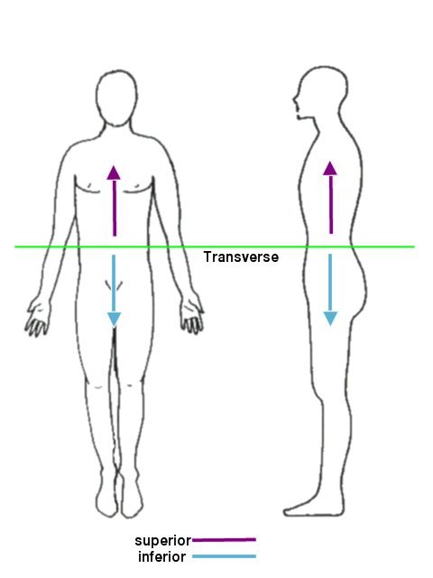

The terms Anterior and Posterior are relative to the Coronal Plane

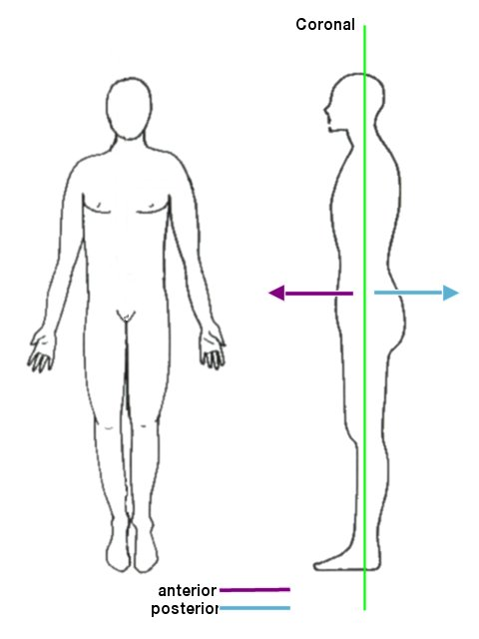

For example: the chest is inferior to the head, but superior to the abdomen and lower limb.

Movement

The following terms are used when referring to movement in the limbs:

Abduction

Adbuction refers to movement in the coronal plane away from the body. A limb further away from the median is regarded as abducted.

Adduction

Adbuction refers to movement in the coronal plane towards the body. A limb in the anatomical position is regarded as abducted.

Proximal

Proximal is a relative term describing the position of one part of a limb relative to the body. If a part of the limb is proximal, it is regarded as being nearer the body, i.e. the elbow is proximal to the wrist.

Distal

Distal is a relative term describing the position of one part of a limb relative to the body. If a part of the limb is distal, it is regarded as being further from body, i.e. the elbow is distal to the shoulder.
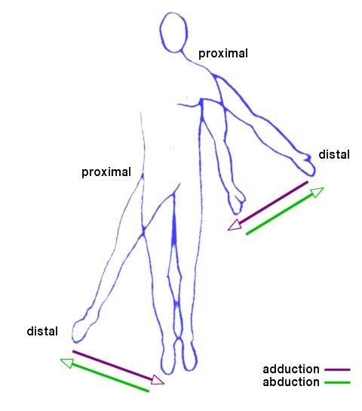
Fig.3 Movement of the limbs.

Bending and stretching are known as flexion and extension respectively:
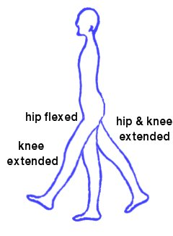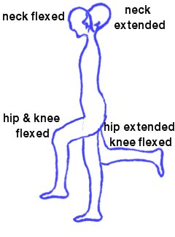
Fig.4 Hip, knee and neck.
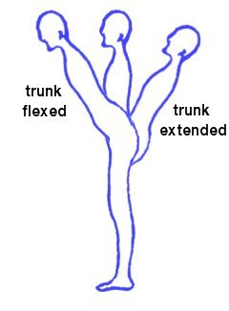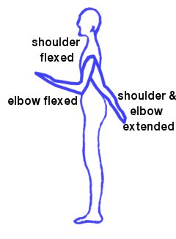
Fig.5 Trunk, shoulder and elbow.

